**Query all columns for all American cities in CITY with populations larger than 100000. The CountryCode for America is USA.**

**Input Format**

**The CITY table is described as follows**

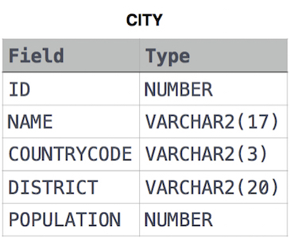

SELECT *

FROM CITY

WHERE POPULATION > 100000 AND COUNTRYCODE LIKE 'USA';